

**FPTU Club Management System**

**Software Requirement Specification**

– Ho Chi Minh City, July 2022 –

**Table of Contents**

**I. Overview** **4**

1. Introduction 4

2. Business Process 5

a. Registration process 5

b. Posting announcements 5

3. System functions 6

a. Screen flow 6

b. Screen details 7

c. User authorization 7

d. Non-screen function 8

e. State transition diagrams 8

i. Club application form 8

**II. Functional Requirements** **10**

1. Login by FPT Gmail 10

2. Submit an application form to join a club 10

3. Check the application status 11

4. Edit personal information 11

5. Register for an event 12

6. View club lists and details 13

7. Read announcements posted by the club managers 14

9. Post or update content by club manager. 16

a. Post club events or announcements. 16

b. Update club events or announcements. 16

10. Approve new members or kick members by club manager 17

a. Approve new members 17

a.Kick member 18

11. Change positions of club members 19

a. Change positions of club members 19

12. Reprimand or commend members 20

a. Reprimand or commend members 20

13.Add club or delete by Admin 21

a. Add club 21

b. Delete club 22

14. Delete or modify announcements posted by managers 23

a. Delete announcements posted by managers 23

b. Modify announcements posted by managers 24

III. Non-Functional Requirements **25**

# I. Overview

## 1. Introduction

FPTU Club Management System (CMS) aims to be a web application on which FPT University students and club managers can manage their club registration and activities. CMS is intended to replace the current time-consuming and error-prone process which uses paper forms and separated social media websites. With this system, students can register for clubs more conveniently; they can keep track of club events, thanks to a digital calendar that the application provides, and register for these events right on the application. Club managers can use the application to perform registration processing, managing club events and members, as well as posting notifications.

The main users of the application are students and club managers at FPT University of Ho Chi Minh City.

The application is expected to operate well on Chrome web browser.

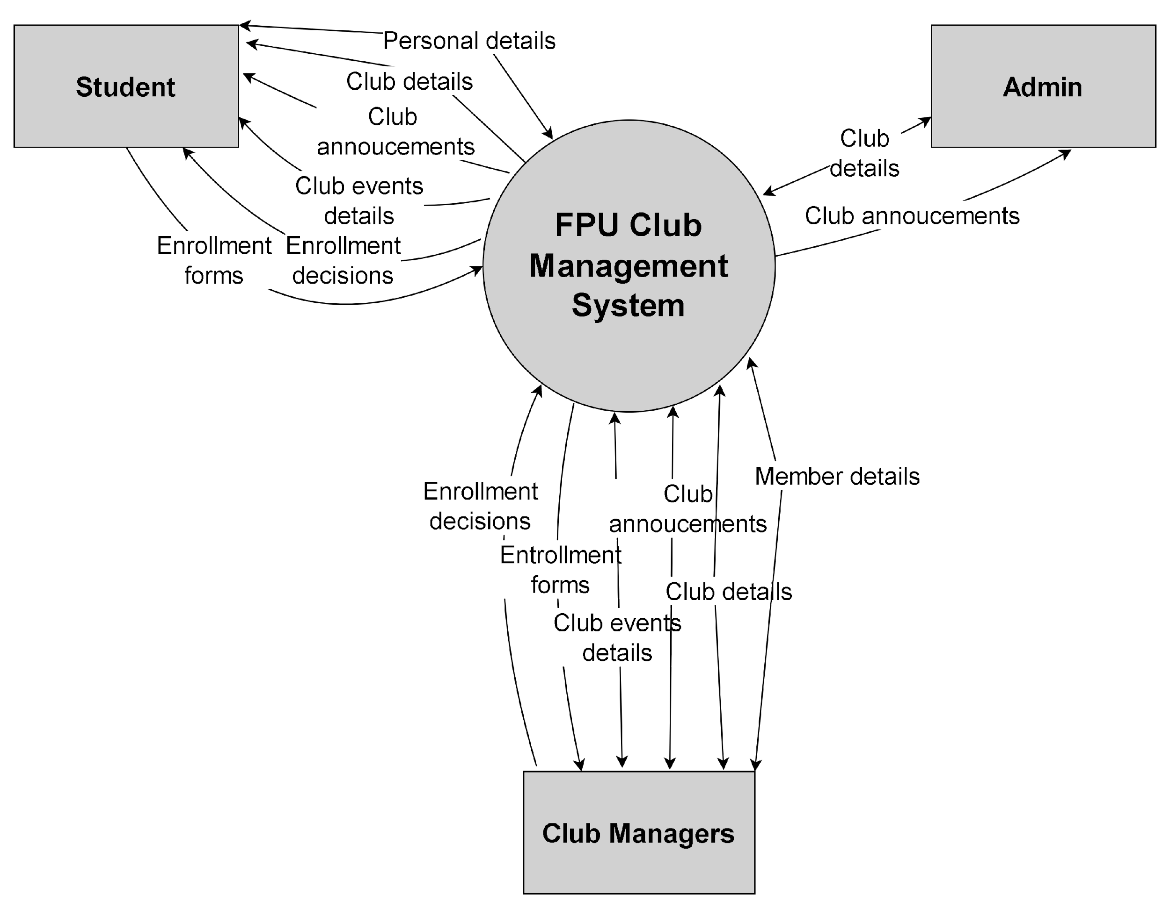

## 2. Business Process

### a. Registration process

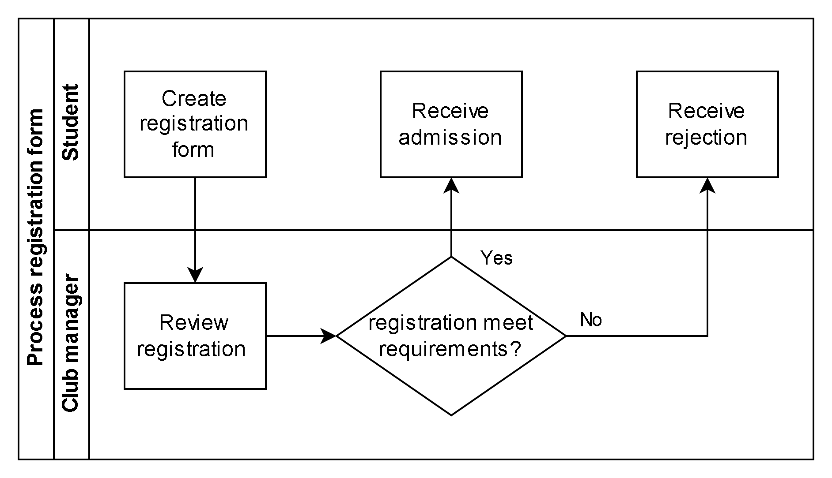

### b. Posting announcements

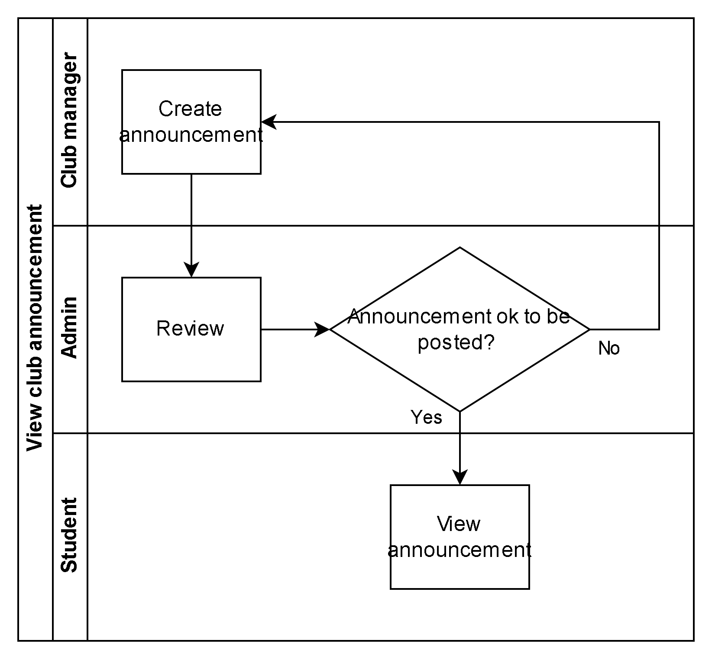

## 

## 3. System functions

### a. Screen flow

#### 

#### 

### b. Screen details

| **#** | **Feature** | **Screen** | **Description** |
| --- | --- | --- | --- |
| 1 | Log in | Login | Authenticate a user to give him/her access to authorised features. Users must log in with FPT University emails |
| 2 | Manage user information | User profile | Users can view and edit their personal information |
| 3 | View club list | Club list (student) | Students can view the list of active clubs at the university |
| $ | Submit registration form | Club registration form | A student can send a registration form to a club manager |
| 5 | View registration result | Registration result list | A student can view the results of the registration forms he/she has submitted |
| 6 | View announcement | Announcement list | A student can view the announcements from all the clubs he/she is a member of |
| 7 | View event calendar | Calendar (student) | A student can view the events of all the clubs he/she is a member of on a calendar |
| 8 | Manage club members | Member list | A club manager can view the list of the members of the club he/she manages. He/she can also edit the members’ details such as positions in the club, rewards, reprimands, etc. |
| 9 | Manage club announcements (manager) | Announcement list (manager) | A club manager can add/edit announcements for the club he/she manages |
| 10 | Manage club registration forms | Registration list | A club manager can view the list of registration forms for the club. He/she can approve/reject the registrations. |
| 11 | Add/Edit Club event | Calendar (manager) | A club manager can add/edit events for the club he/she manages |
| 12 | Edit club details | Edit club detail | A club manager can edit the information about the club he/she manages |
| 13 | Manage club announcement (admin) | Announcement list (admin) | An admin can edit/delete announcements of clubs |
| 14 | Manage club (admin) | Club list (admin) | An admin can add/delete a club |

### c. User authorization

| **Screen** | **Student** | **Club manager** | **Admin** |
| --- | --- | --- | --- |
| Login | X | X | X |
| User profile | X | X | X |
| Club list | X |  | X |
| Add a club |  |  | X |
| Delete a club |  |  | X |
| Club registration form | X |  |  |
| Registration result list | X |  |  |
| Announcement list | X | X | X |
| Post announcement |  | X |  |
| Edit announcement |  | X | X |
| Calendar |  |  |  |
| Register for event | X |  |  |
| Add event |  | X |  |
| Edit event |  | X |  |
| Edit club detail |  | X |  |
| Member list |  | X |  |
| Registration list |  | X |  |

In which:

* Student: a student at FPT University of Ho Chi Minh city
* Club manager: a manager of a club at FPT University of Ho Chi Minh city
* Admin: an admin of FPTU CMS system

### d. Non-screen function

| **#** | **Feature** | **System Function** | **Description** |
| --- | --- | --- | --- |
| 1 | Registration management | Email notification | When a club manager has given the result for a registration form, an email will be sent to the student’s FPTU email to notify the student. |

### e. State transition diagrams

#### i. Club application form

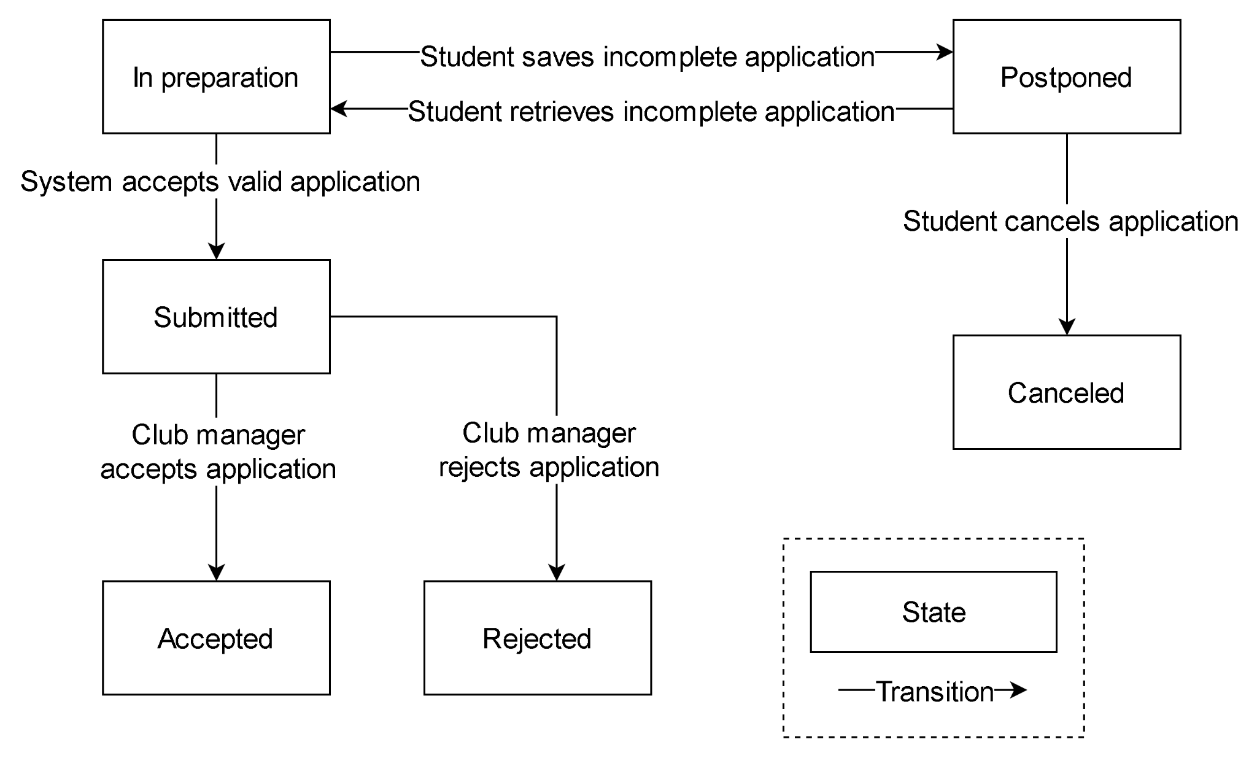

***ii. Club announcement***

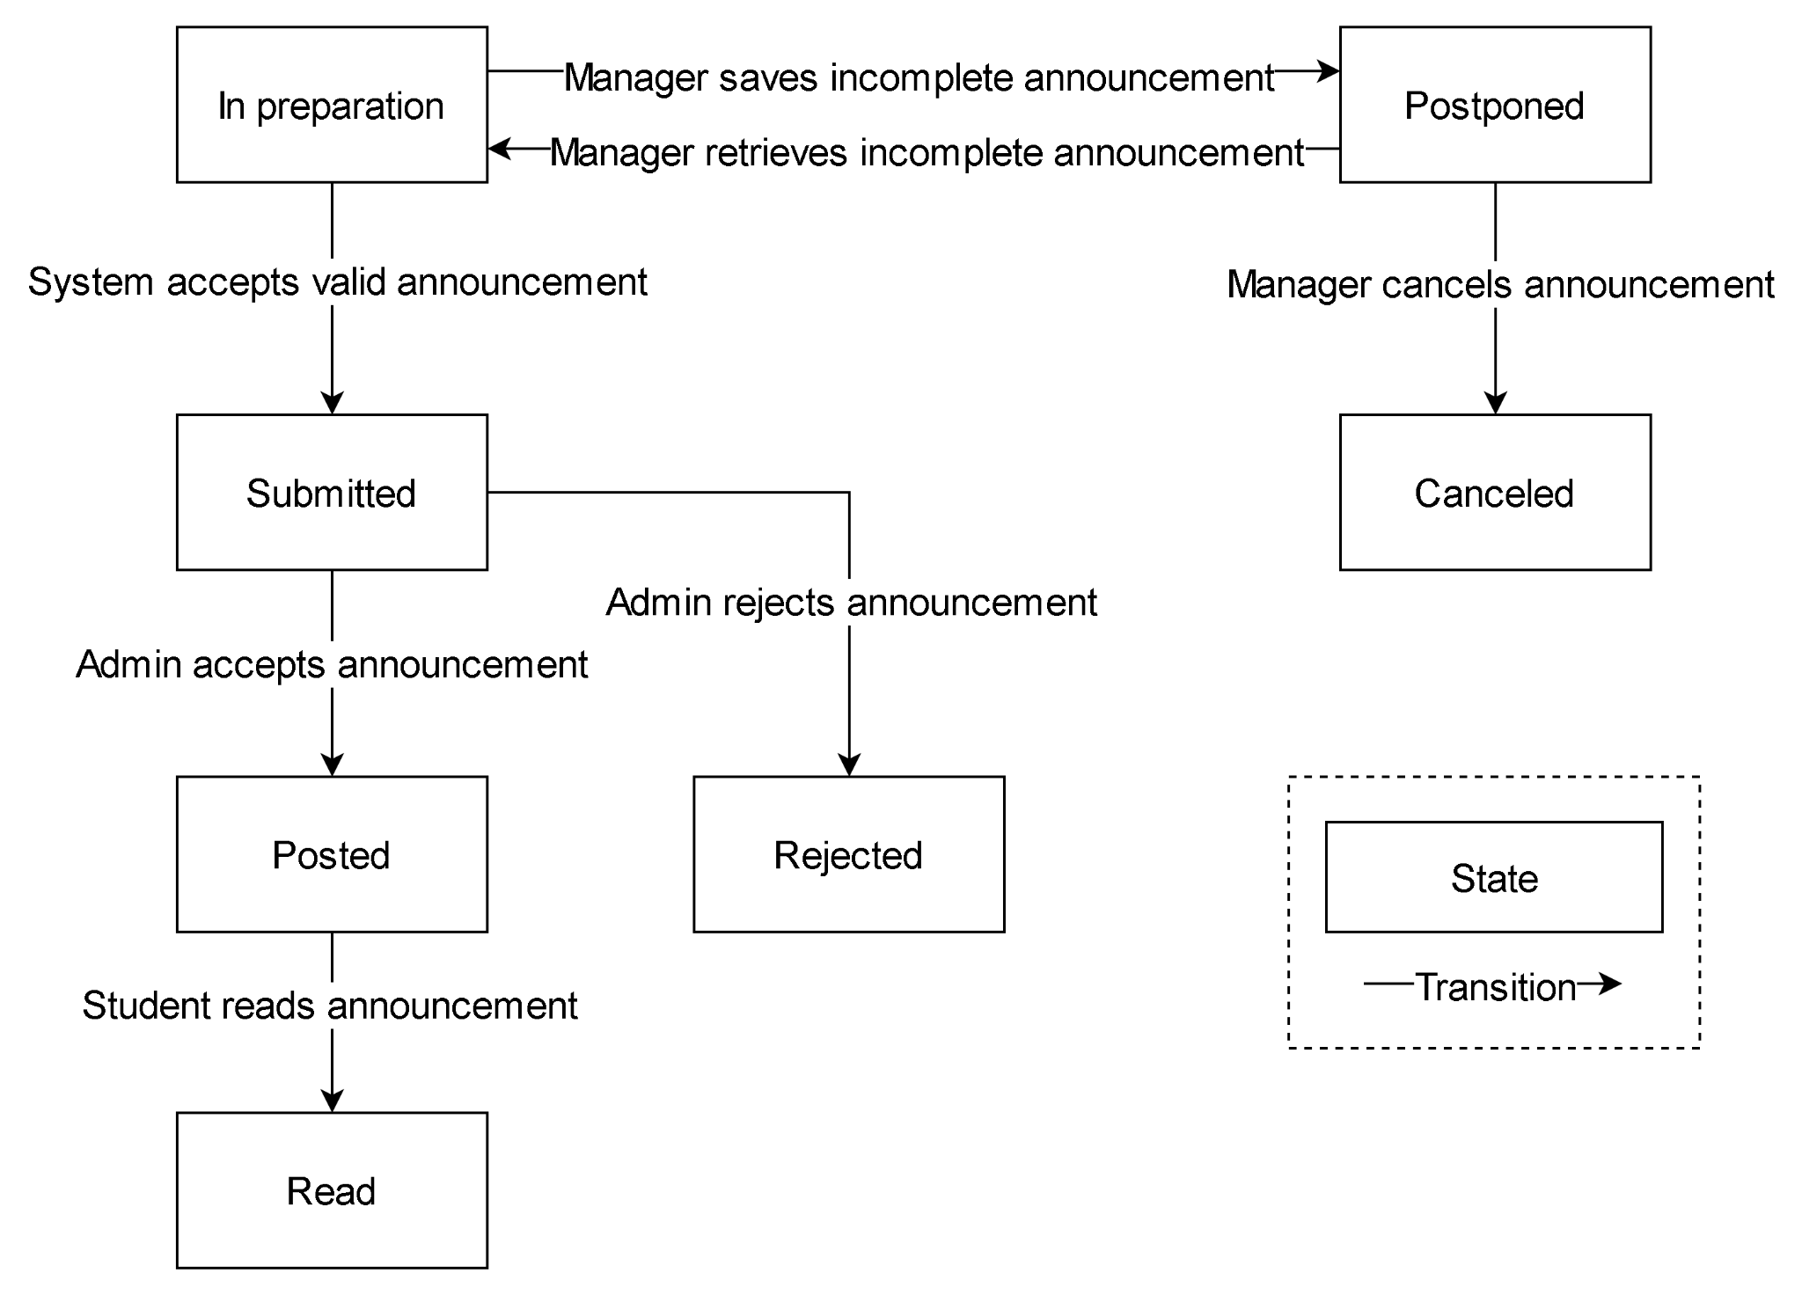

# 

# II. Functional Requirements

## 1. Login by FPT Gmail

* Function trigger: clicking on “Sign in with email” button on homepage
* Description: User signs in with a connected email
* Screen layout:



- Details: The system checks if the email is registered in the database. If yes, the user is logged in. If not, a warning message is sent to the browser.

## 2. Submit an application form to join a club

* Function trigger: clicking on the “Application Form ” link in the club app.
* Description: User login in the app by the FPTU email can fill in the form.
* Screen layout:

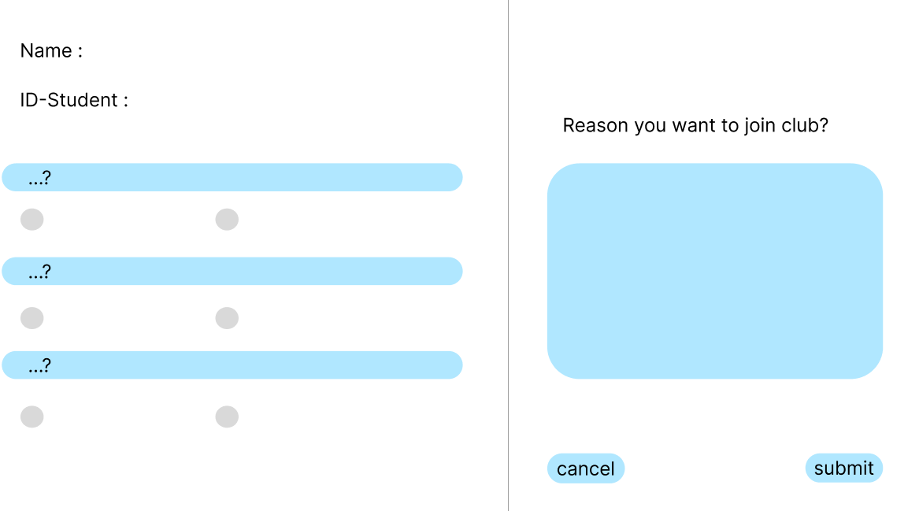

- Details: The system checks if the email is registered in the database . If yes, the form will be sended to the Club manager email, waiting to be confirmed.

## 3. Check the application status

* Function trigger: user check the status of the form by the status section in the user information.
* Description: User login by the FPTU email and fill in the application form can check it.
* Screen layout:

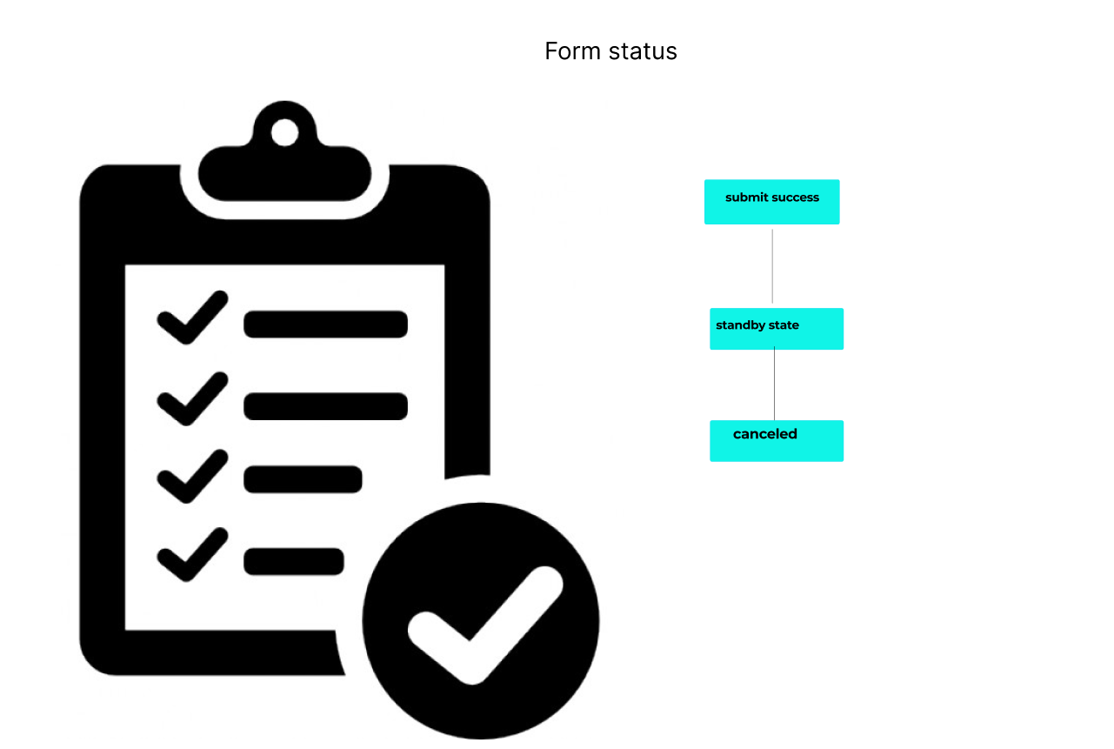

* Details: The system checks if the application is “accepted” or not(the time maximum of check is two days). If not, the application mark “rejected”.

## 4. Edit personal information

* Function trigger: user click on the “change the status “ button in the user ‘ profile.
* Description: User login by the FPTU email, facebook account can use this .
* Screen layout:

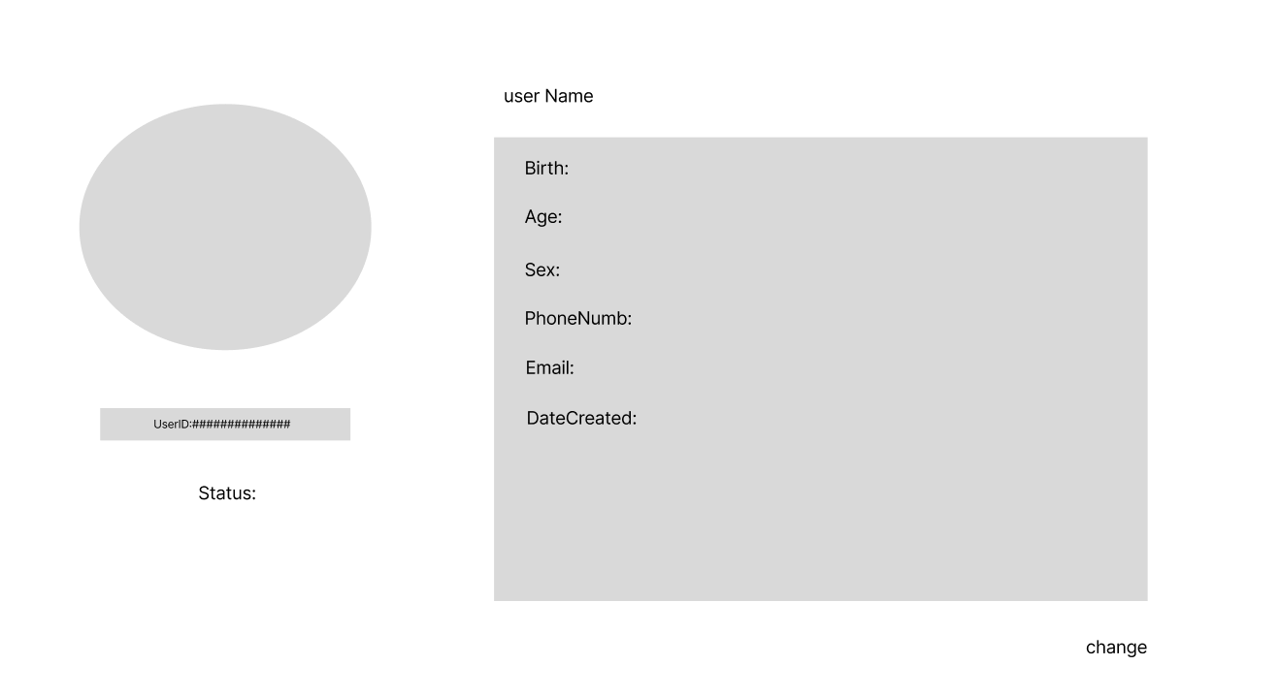

* Details: The system checks if the account is registered in the database. If yes, the user account is changed. If not, a warning message is sent to the browser.

## 5. Register for an event

* Function trigger: user click on the “register for the event “ link in the “announcement for the event ”post of the club .
* Description: User login by the FPTU email, facebook account can use this. Some events are for the FPTU student only.Therefor, people login in to the app by facebook can not enter it .
* Screen layout:

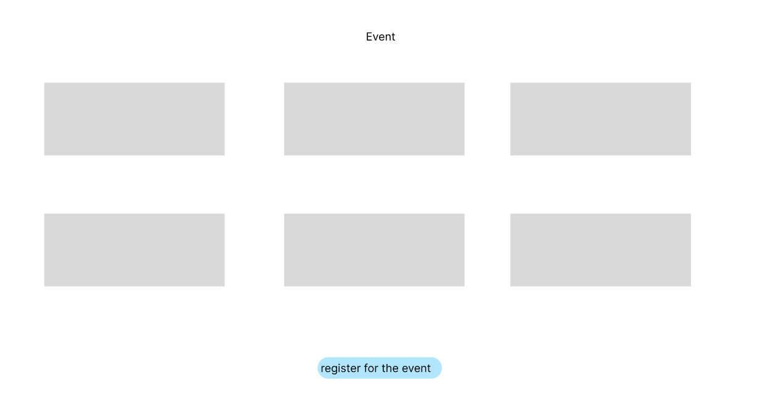

* Details: The system checks if the account is registered in the database. If yes, the system will show the result of success enter. If not, the sorry form is appeared.

## 

## 6. View club lists and details

* Function trigger :user click on the “see the club list and details “ button in the app.
* Description: user login by the FPTU email, facebook account can use this .
* Screen layout:

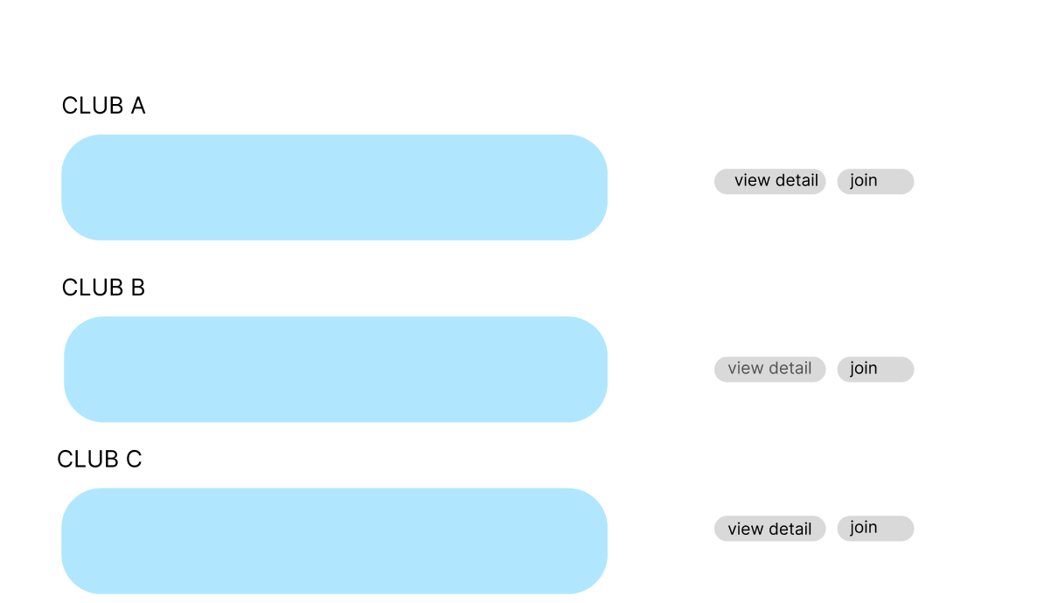

- Details: The system checks if the account is registered in the database. If yes, the user can see the club and details. If not, a warning message is sent to the browser.

## 

## 7. Read announcements posted by the club managers

* Function trigger :user click on the “news “ link in the app.
* Description: User login by the FPTU email, facebook account or the one not registered can use this.
* Screen layout:

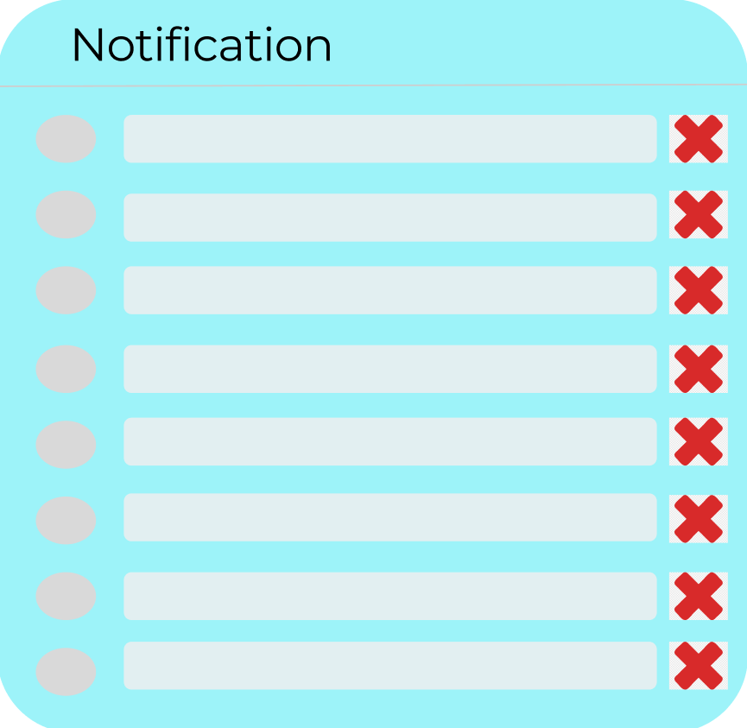

- Details: user can see the news of the club manager. But, some news is for the FPTU student only, the one sign in with facebook account or not registered can not read it.

Club Manager:



**8. Retrieve application form and give result**

* Function trigger : club manager click on the “ application “ link in the app.
* Description: User login by the FPTU club manager email.
* Screen layout:

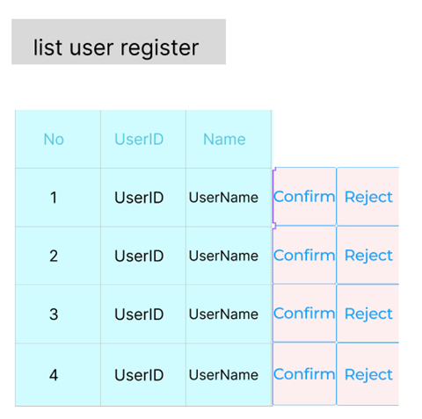

* Details: club manager will get a notification when some one registered. He /she can check the application in the app. Then he/she can decide to approve or not.

## 

## 9. Post or update content by club manager.

### a. Post club events or announcements.

* Function trigger: Club manager click on “Add post” button in navigator sidebar
* Function description: Function used for Club manager, This function for club manager to post information for the club members to know.
* Screen layout: mockup prototype of the screen, sample below is for Add post screen

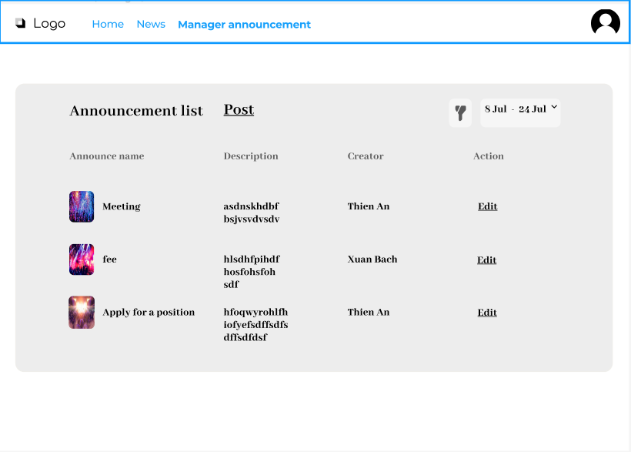

* Function Detail:

Manager click on “Add post button” and then manager chooses the type of post. Manager fills the form for the type of post and then choose Save or Cancel button. If manager chooses Cancel button the System will back to type of post and not cancel that form. If manager click Save button and click on Post The FPTU CMS will ask manager to confirm.. The popup will turn on and Manager will chooses Ok or Cancel click. If manager chooses Cancel the FPTU CMS will back to form that was written before. If Manager click Ok FPTU CMS notifies the piece of information has been posted.

### b. Update club events or announcements.

* Function trigger: Club manager click on “Edit post” button in navigator sidebar
* Function description: Function used for Club manager, This function for club manager to update information for the club members to know.
* Screen layout: mockup prototype of the screen, sample below is for Edit post screen



* Function Detail:

Manager click on “Edit post button” and then manager chooses the type of post.

FPTU CMS shows the list of posts of the chosen type . Manager clicks on “Edit” next to a post listing and then manager edits the content of the post . Manager chooses button Save or Cancel. If manager click Cancel button system will back to edit content of post. If manager click Save button The FPTU CMS will ask manager to comfirms. The popup will turn on and Manager will chooses Ok or Cancel. If manager chooses Cancel the FPTU CMS will back to Edit post page. If Manager click Ok FPTU CMS notefies the piece of information has been edited.

## 

## 10. Approve new members or kick members by club manager

### a. Approve new members

* Function trigger: Admin click on “Manage team members” button in navigator sidebar, system will forward to Manage team members page and then click approve button.
* Function description: Function used for clubs manager, with this function admin can approve new members.
* Screen layout: mockup prototype of the screen, sample below is for approve new members screen

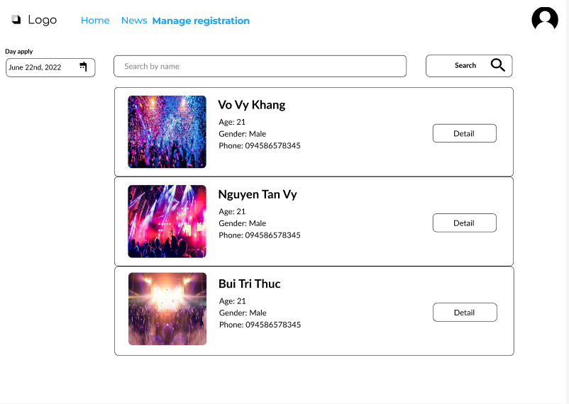

* Function Detail: The manager opens the application list by clicking on the application list button. FPTU CMS displays all applications submitted to the system. Manager clicks on the detail button on each application to see details. FPTU CMS displays the details of the selected application. The administrator clicks the accept button. FPTU CMS confirms the new data has been saved. FPTU CMS stores the new data. FPTU CMS displays a message that successfully added new member. FPT CMS sends notification that the application has been approved or rejected to email or registered phone number.

### a.Kick member

* Function trigger: Admin click on “Manage team members” button in navigator sidebar, system will forward to Manage team members page and then click kick button.
* Function description: Function used for clubs manager, with this function admin can kick members out of group.
* Screen layout: mockup prototype of the screen, sample below is for kick member screen

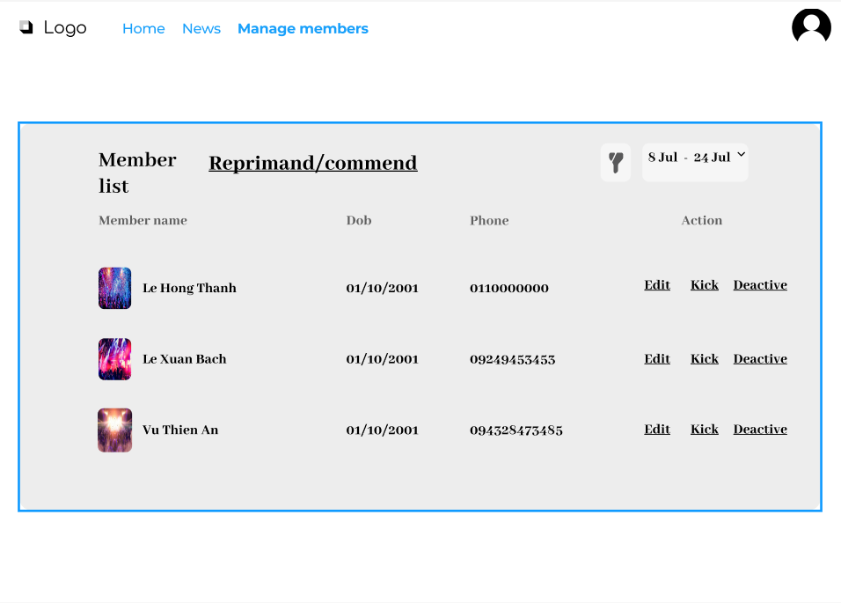

* Function Detail: The manager opens the member list by clicking on the member list button. FPTU CMS displays all members of the system. Manager clicks on the detail button on each member to see details. FPTU CMS displays the details of the selected member. The administrator clicks on the delete button. The confirmation dialog box is displayed. The manager selects the delete button. Member removed from the system. The system confirms and updates the information. FPTU CMS displays a message that successfully removed member.

## 

## 11. Change positions of club members

### a. Change positions of club members

* Function trigger: Club manager click on “promote/demote” button in navigator sidebar
* Function description: Function used for Club manager, with this function clubs manager can can change positions of club members.
* Screen layout: mockup prototype of the screen, sample below is for change position screen

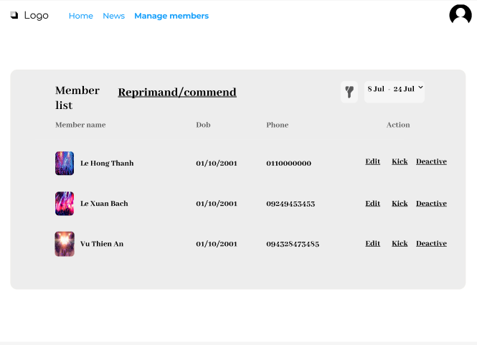

* Function Detail: Manager clicks on the promote/demote button. FPTU CMS displays all members of the system. The manager clicks on the detail button. FPTU CMS displays that member's achievements and appointment score compared to other members. Manager clicks on the promote button. The system confirms and updates the information. FPTU CMS displays a successful position transfer message. If manager click on the demote button, the system confirms and updates the information. FPTU CMS displays a successful position transfer message. If the position is already full, the position transfer will not be successful.

## 12. Reprimand or commend members

### a. Reprimand or commend members

* Function trigger: Club manager click on “commend/reprimand” button in navigator sidebar
* Function description: Function used for Club manager, with this function clubs manager can reprimand or commend members.
* Screen layout: mockup prototype of the screen, sample below is for reprimand or commend screen
* 
* Function Detail: Manager clicks on the commend/reprimand button. FPTU CMS displays all members of the system. The manager clicks on the detail button. FPTU CMS displays the activities participated in and scores from each activity along with feedback from other members. The manager clicks the action button. FPTU CMS displays a detailed description screen. The manager writes a description of why praise or why reprimand in the description text. The manager clicked the commend button. The system confirms and updates the information. FPTU CMS displays a successful execution message. FPTU CMS sends notices to members. If manager click the reprimand button the The system confirms and updates the information, FPTU CMS displays a successful execution message and FPTU CMS sends notices to members.

## 13.Add club or delete by Admin

### a. Add club

* Function trigger: Admin click on “Manage club” button in navigator sidebar, system will forward to manage club page and then click add club button.
* Function description: Function used for Admin, with this function admin can add club.
* Screen layout: mockup prototype of the screen, sample below is for add club screen

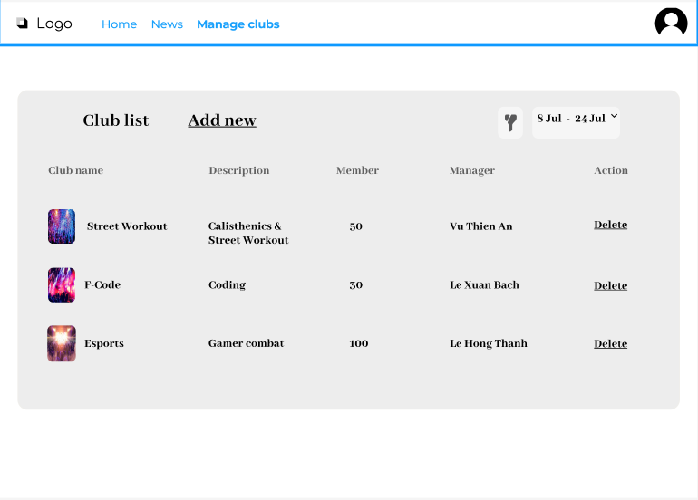

* Function Detail:

Admin click on manage club in navigator side bar. The system will forward admin to manage club page, end then admin click add club button. The system return list all clubs in FPTU CMS. Each clubs display number of members and who is clubs manager. Admin will add new club through accept of clubs managers in real life. The form will display in screen and and fill all basic information of clubs in form and choose Save or Cancel. If admin chooses Cancel the system will back to the form when admin was filled. If admin click Save button, FPTU CMS display notification in screen Add new success! . If the name of the club being added is already in the database, FPTU CMS displays a warning message and asks the admin to enter another name.

### b. Delete club

* Function trigger: Admin click on “Manage club” button in navigator sidebar, system will forward to manage club page and then click delete club button.
* Function description: Function used for Admin, with this function admin can delete club.
* Screen layout: mockup prototype of the screen, sample below is for delete club screen



* Function Detail:

Admin click on manage club in navigator side bar. The system will forward admin to manage club page. The system return list all clubs in FPTU CMS. Each clubs display number of members and who is clubs manager, end then admin click delete club button. Admin will delete club club through accept of clubs managers in real life.. FPTU CMS display popup warning: “Are you sure about deleteing this club?” and chooses Ok or Cancel. If admin chooses Cancel the system will back to display number of members and who is clubs manager in each clubs. If admin click Ok button, FPTU CMS displays a successful delete . If the name of the club being added is already in the database, FPTU CMS displays a warning message and asks the admin to enter another name. After deleting the app will save the deleted history of who and what has been deleted.

## 14. Delete or modify announcements posted by managers

### a. Delete announcements posted by managers

- Function trigger: Admin click on “Manage content club” button in navigator sidebar, system will forward to manage content page and then click delete button.

- Function description: Function used for Admin, with this function admin can delete announcements posted by managers.

- Screen layout: mockup prototype of the screen, sample below is for delete announcements posted by managers screen

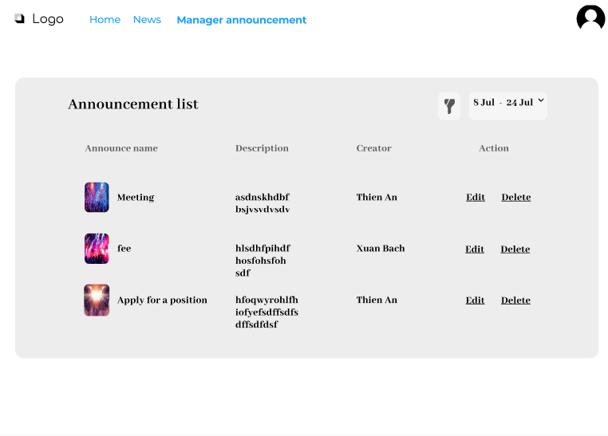

- Function Detail: Admin click on “Manage content club” button in navigator sidebar, Admin view list all clubs in FPTU CMS, each clubs display number of members and who is clubs manager. Admin click on club and choose announcements item. FPTU CMS list all announcements of club from newest to oldest by date. Admin click on delete button next to each announcement and delete that announcement. And then FPTU CMS display popup warning: “Are you sure about deleting this announcement?”, Admin chooses Ok or Cancel button. If admin chooses Cancel system forward admin to list all announcements of club from newest to oldest by date. If admin click Ok FPTU CMS displays a successful delete. After deleting, the app will save the deleted history of who and what has been deleted.

### b. Modify announcements posted by managers

- Function trigger: Admin click on “Manage content club” button in navigator sidebar, system will forward to manage content page and then click modify button.

- Function description: Function used for Admin, with this function admin can modify announcements posted by managers.

- Screen layout: mockup prototype of the screen, sample below is for modify announcements posted by managers screen



- Function Detail:.

Admin click on “Manage content club” button in navigator sidebar Admin view list all clubs in FPTU CMS, each clubs display number of members and who is clubs manager. Admin click on club and choose announcements item. FPTU CMS list all announcements of club from newest to oldest by date. Admin click on modify button next to each announcement and edit that announcement. Admin chooses Save or Cancel for change that announcement. If user click Cancel system back to list all announcements of club from newest to oldest by date. If user click Save, FPTU CMS display in screen update success. After modify, the app will save the deleted history of who and what has been modified.

# III. Non-Functional Requirements

1. The application can run on Chrome web browser.
2. This application gets its data from the school's current SQL server.